Operating Systems Lab #12

Name: Ahmed Kasteer
Roll Number: 20F-0336
Section: 4D

Dinning Philosopher Problem
#include <pthread.h>
#include <semaphore.h>
#include <stdio.h>
#include<unistd.h>
#define N 5
#define THINKING 2
#define HUNGRY 1
#define EATING 0
#define LEFT (phnum + 4) % N
#define RIGHT (phnum + 1) % N

int state[N];
int phil[N] = { 0, 1, 2, 3, 4 };

sem_t mutex;
sem_t S[N];

void test(int phnum)
{
if (state[phnum] == HUNGRY
&& state[LEFT] != EATING
&& state[RIGHT] != EATING) {
// state that eating
state[phnum] = EATING;

sleep(2);

printf("Philosopher %d takes fork %d and %d\n",
phnum + 1, LEFT + 1, phnum + 1);

printf("Philosopher %d is Eating\n", phnum + 1);

// sem_post(&S[phnum]) has no effect
// during takefork
// used to wake up hungry philosophers
// during putfork
sem_post(&S[phnum]);
}
}

// take up chopsticks
void take_fork(int phnum)
{

sem_wait(&mutex);

// state that hungry
state[phnum] = HUNGRY;

printf("Philosopher %d is Hungry\n", phnum + 1);

// eat if neighbours are not eating
test(phnum);

sem_post(&mutex);

// if unable to eat wait to be signalled
sem_wait(&S[phnum]);

sleep(1);
}

// put down chopsticks
void put_fork(int phnum)
{

sem_wait(&mutex);

// state that thinking
state[phnum] = THINKING;

printf("Philosopher %d putting fork %d and %d down\n",
phnum + 1, LEFT + 1, phnum + 1);
printf("Philosopher %d is thinking\n", phnum + 1);

test(LEFT);
test(RIGHT);

sem_post(&mutex);
}

void* philosopher(void* num)
{

while (1) {

int* i = num;

sleep(1);

take_fork(*i);

sleep(0);

put_fork(*i);
}
}

int main()
{

int i;
pthread_t thread_id[N];

// initialize the semaphores
sem_init(&mutex, 0, 1);

for (i = 0; i < N; i++)

sem_init(&S[i], 0, 0);

for (i = 0; i < N; i++) {

// create philosopher processes
pthread_create(&thread_id[i], NULL,
philosopher, &phil[i]);

printf("Philosopher %d is thinking\n", i + 1);
}

for (i = 0; i < N; i++)

pthread_join(thread_id[i], NULL);
}
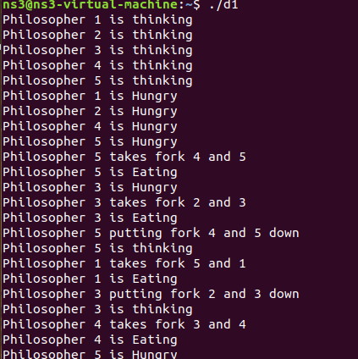

Reader-Writer Problem
#include <pthread.h>
#include <semaphore.h>
#include <stdio.h>

/*
This program provides a possible solution for first readers writers problem using mutex and semaphore.
I have used 10 readers and 5 producers to demonstrate the solution. You can always play with these values.
*/

sem_t wrt;
pthread_mutex_t mutex;
int cnt = 1;
int numreader = 0;

void *writer(void *wno)
{
sem_wait(&wrt);
cnt = cnt*2;
printf("Writer %d modified cnt to %d\n",(*((int *)wno)),cnt);
sem_post(&wrt);

}
void *reader(void *rno)
{
// Reader acquire the lock before modifying numreader
pthread_mutex_lock(&mutex);
numreader++;
if(numreader == 1) {
sem_wait(&wrt); // If this id the first reader, then it will block the writer
}
pthread_mutex_unlock(&mutex);
// Reading Section
printf("Reader %d: read cnt as %d\n",*((int *)rno),cnt);

// Reader acquire the lock before modifying numreader
pthread_mutex_lock(&mutex);
numreader--;
if(numreader == 0) {
sem_post(&wrt); // If this is the last reader, it will wake up the writer.
}
pthread_mutex_unlock(&mutex);
}

int main()
{

pthread_t read[10],write[5];
pthread_mutex_init(&mutex, NULL);
sem_init(&wrt,0,1);

int a[10] = {1,2,3,4,5,6,7,8,9,10}; //Just used for numbering the producer and consumer

for(int i = 0; i < 10; i++) {
pthread_create(&read[i], NULL, (void *)reader, (void *)&a[i]);
}
for(int i = 0; i < 5; i++) {
pthread_create(&write[i], NULL, (void *)writer, (void *)&a[i]);
}

for(int i = 0; i < 10; i++) {
pthread_join(read[i], NULL);
}
for(int i = 0; i < 5; i++) {
pthread_join(write[i], NULL);
}

pthread_mutex_destroy(&mutex);
sem_destroy(&wrt);

return 0;

}
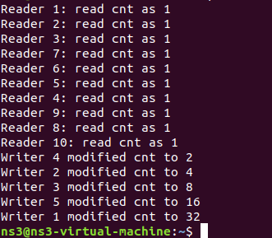

Producer Consumer Problem
// C program for the above approach

#include <stdio.h>
#include <stdlib.h>

// Initialize a mutex to 1
int mutex = 1;

// Number of full slots as 0
int full = 0;

// Number of empty slots as size
// of buffer
int empty = 10, x = 0;

// Function to produce an item and
// add it to the buffer
void producer()
{
// Decrease mutex value by 1
--mutex;

// Increase the number of full
// slots by 1
++full;

// Decrease the number of empty
// slots by 1
--empty;

// Item produced
x++;
printf("\nProducer produces"
"item %d",
x);

// Increase mutex value by 1
++mutex;
}

// Function to consume an item and
// remove it from buffer
void consumer()
{
// Decrease mutex value by 1
--mutex;

// Decrease the number of full
// slots by 1
--full;

// Increase the number of empty
// slots by 1
++empty;
printf("\nConsumer consumes "
"item %d",
x);
x--;

// Increase mutex value by 1
++mutex;
}

// Driver Code
int main()
{
int n, i;
printf("\n1. Press 1 for Producer"
"\n2. Press 2 for Consumer"
"\n3. Press 3 for Exit");

// Using '#pragma omp parallel for'
// can give wrong value due to
// synchronization issues.

// 'critical' specifies that code is
// executed by only one thread at a
// time i.e., only one thread enters
// the critical section at a given time
#pragma omp critical

for (i = 1; i > 0; i++) {

printf("\nEnter your choice:");
scanf("%d", &n);

// Switch Cases
switch (n) {
case 1:

// If mutex is 1 and empty
// is non-zero, then it is
// possible to produce
if ((mutex == 1)
&& (empty != 0)) {
producer();
}

// Otherwise, print buffer
// is full
else {
printf("Buffer is full!");
}
break;

case 2:

// If mutex is 1 and full
// is non-zero, then it is
// possible to consume
if ((mutex == 1)
&& (full != 0)) {
consumer();
}

// Otherwise, print Buffer
// is empty
else {
printf("Buffer is empty!");
}
break;

// Exit Condition
case 3:
exit(0);
break;
}
}
}

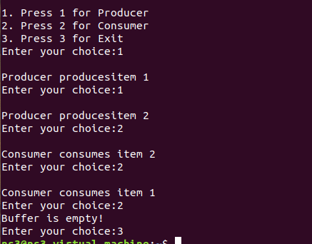

Peterson Problem

// C program to implement Peterson’s Algorithm
// for producer-consumer problem.
#include <stdio.h>
#include <stdlib.h>
#include <unistd.h>
#include <time.h>
#include <sys/types.h>

#include <sys/ipc.h>
#include <sys/shm.h>
#include <stdbool.h>
#define _BSD_SOURCE
#include <sys/time.h>
#include <stdio.h>

#define BSIZE 8 // Buffer size
#define PWT 2 // Producer wait time limit
#define CWT 10 // Consumer wait time limit
#define RT 10 // Program run-time in seconds

int shmid1, shmid2, shmid3, shmid4;
key_t k1 = 5491, k2 = 5812, k3 = 4327, k4 = 3213;
bool* SHM1;
int* SHM2;
int* SHM3;

int myrand(int n) // Returns a random number between 1 and n
{
time_t t;
srand((unsigned)time(&t));
return (rand() % n + 1);
}

int main()
{
shmid1 = shmget(k1, sizeof(bool) * 2, IPC_CREAT | 0660); // flag
shmid2 = shmget(k2, sizeof(int) * 1, IPC_CREAT | 0660); // turn
shmid3 = shmget(k3, sizeof(int) * BSIZE, IPC_CREAT | 0660); // buffer
shmid4 = shmget(k4, sizeof(int) * 1, IPC_CREAT | 0660); // time stamp

if (shmid1 < 0 || shmid2 < 0 || shmid3 < 0 || shmid4 < 0) {
perror("Main shmget error: ");
exit(1);
}
SHM3 = (int*)shmat(shmid3, NULL, 0);
int ix = 0;
while (ix < BSIZE) // Initializing buffer
SHM3[ix++] = 0;

struct timeval t;
time_t t1, t2;
gettimeofday(&t, NULL);
t1 = t.tv_sec;

int* state = (int*)shmat(shmid4, NULL, 0);
*state = 1;
int wait_time;

int i = 0; // Consumer
int j = 1; // Producer

if (fork() == 0) // Producer code
{
SHM1 = (bool*)shmat(shmid1, NULL, 0);
SHM2 = (int*)shmat(shmid2, NULL, 0);
SHM3 = (int*)shmat(shmid3, NULL, 0);
if (SHM1 == (bool*)-1 || SHM2 == (int*)-1 || SHM3 == (int*)-1) {
perror("Producer shmat error: ");
exit(1);
}

bool* flag = SHM1;
int* turn = SHM2;
int* buf = SHM3;
int index = 0;

while (*state == 1) {
flag[j] = true;
printf("Producer is ready now.\n\n");
*turn = i;
while (flag[i] == true && *turn == i)
;

// Critical Section Begin
index = 0;
while (index < BSIZE) {
if (buf[index] == 0) {
int tempo = myrand(BSIZE * 3);
printf("Job %d has been produced\n", tempo);
buf[index] = tempo;
break;
}
index++;
}
if (index == BSIZE)
printf("Buffer is full, nothing can be produced!!!\n");
printf("Buffer: ");
index = 0;
while (index < BSIZE)
printf("%d ", buf[index++]);
printf("\n");
// Critical Section End

flag[j] = false;
if (*state == 0)
break;
wait_time = myrand(PWT);
printf("Producer will wait for %d seconds\n\n", wait_time);
sleep(wait_time);
}
exit(0);
}

if (fork() == 0) // Consumer code
{
SHM1 = (bool*)shmat(shmid1, NULL, 0);
SHM2 = (int*)shmat(shmid2, NULL, 0);
SHM3 = (int*)shmat(shmid3, NULL, 0);
if (SHM1 == (bool*)-1 || SHM2 == (int*)-1 || SHM3 == (int*)-1) {
perror("Consumer shmat error:");
exit(1);
}

bool* flag = SHM1;
int* turn = SHM2;
int* buf = SHM3;
int index = 0;
flag[i] = false;
sleep(5);
while (*state == 1) {
flag[i] = true;
printf("Consumer is ready now.\n\n");
*turn = j;
while (flag[j] == true && *turn == j)
;

// Critical Section Begin
if (buf[0] != 0) {
printf("Job %d has been consumed\n", buf[0]);
buf[0] = 0;
index = 1;
while (index < BSIZE) // Shifting remaining jobs forward
{
buf[index - 1] = buf[index];
index++;
}
buf[index - 1] = 0;
} else
printf("Buffer is empty, nothing can be consumed!!!\n");
printf("Buffer: ");
index = 0;
while (index < BSIZE)
printf("%d ", buf[index++]);
printf("\n");
// Critical Section End

flag[i] = false;
if (*state == 0)
break;
wait_time = myrand(CWT);
printf("Consumer will sleep for %d seconds\n\n", wait_time);
sleep(wait_time);
}
exit(0);
}
// Parent process will now for RT seconds before causing child to terminate
while (1) {
gettimeofday(&t, NULL);
t2 = t.tv_sec;
if (t2 - t1 > RT) // Program will exit after RT seconds
{
*state = 0;
break;
}
}
// Waiting for both processes to exit

printf("The clock ran out.\n");
return 0;
}

